Software Testing LO5
Samad Ali
This document details quality assurance processes which were applied to the ILP medical drone delivery system. I will formally review areas of the code, design a Continuous Integration (CI) pipeline, and demonstrate how this ensures system integrity.
5.1 Code Reviews and Inspections
For these reviews, I will focus on Functionality, Readability, Efficiency and Robustness. I selected the PathService and DroneService classes as these are the most complex areas of the system.
Review of PathService.findPath()
The findPath method implements the A* search algorithm, used to navigate to the delivery location. (R1 – Navigation)
Strengths
- Efficiency, I used a PriorityQueue which ensures that the most promising nodes are explored first. This keeps the search space optimal at all times.
- Safety, integrating doesLineIntersectPolygon directly into the neighbor exploration loop ensures the drone will never move through a no-fly zone (also avoiding corner-cutting).
Issues + Solution
- Issue: The coordinate keying system originally used a simple string concatenation: pos.lng() + "," + pos.lat()
- Risk: In a long running calculation, floating-point precision differences could lead to the same physical location having two different string keys, causing the algorithm to re-explore the same point.
- Solution: I implemented a more robust key() function that rounds coordinates to a consistent precision.
Review of DroneService.checkCondition()
This uses the Jackson library to evaluate queries against drone capabilities. (R2)
Strengths
- Flexibility, JsonNode.findValue(attribute) allows the service to handle nested attributes within the drone's capability object (no hardcoded path to the field necessary).
- Readability, use of switch expressions makes the logic for different operators (<, >, =, !=) concise and easy to find.
Issues + Solution
- Issue: The initial implementation of Double.parseDouble(value) lacked error handling.
- Risk: If the ILP service returned a non-numeric string for a numeric field, the process would crash with a NumberFormatException.
- Solution: I added a try-catch block within the numerical branch to log a warning and return false gracefully, satisfying the robustness criteria from LO3.
5.2 Construction of CI Pipeline
To automate quality control, I designed a Continuous Integration pipeline using GitHub Actions. This ensures that whenever there’s a code change, it is verified against the test suite before being merged.
Pipeline Stages
- Trigger – The pipeline will be triggered on every push to the main request and on every pull request.
- Environment – The runner intialises a Linux environment with JDK 21 and necessary Maven dependencies.
- Build & Compilation – Runs ‘mvn clean compile’ (syntax errors or broken dependencies will cause build to fail)
- Automated Testing – Runs ‘mvn test’ executing unit, integration and system tests as defined in the test folder.
If all tests pass, code will be allowed to merge into the repository.
5.3 Automation of Testing Processes
Automation is the core of the pipeline. The Maven Surefire plugin is used to run the JUnit tests, and now testing is no longer a manual chore but instead an assurer of code quality.
- The automated suite runs 85 tests in under 60 seconds, these tests would take longer for people to manually verify every time they made a change to the code.
- Regression prevention. Every time I made a change to something, for example the A* search heuristic, the automated test suite would ensure the calculateDistance logic hasn’t been broken.
- Performance, the testCalcDeliveryPathWithRealisticOrders system test ensures that if any code change causes the A* search to take longer than 30 seconds, the CI build fails. This ensures that requirement 3 isn’t broken.
5.4 Demonstration of CI Pipeline functionality
The pipeline acts as a guard for quality and performance. Below are scenarios of how the pipeline would work in action, followed by a screenshot of it running on GitHub.
- Scenario 1 – A developer accidentally changes the closeness threshold from 0.00015 to 0.0015. When they try to push the code, testThresholdBoundaryClosenessCalculation will fail. The GitHub Actions UI shows a red X, and the pull request is blocked from merging.
- Scenario 2 – A developer adds a new dependency but forgets to include it in the pom.xml. The Build stage of the pipeline fails with a "Symbol not found" error, so the developer would find out before the tests even get to run.
- Scenario 3 – All tests pass, the developer receives a green checkmark, they can be confident that their code does not break any functionality.
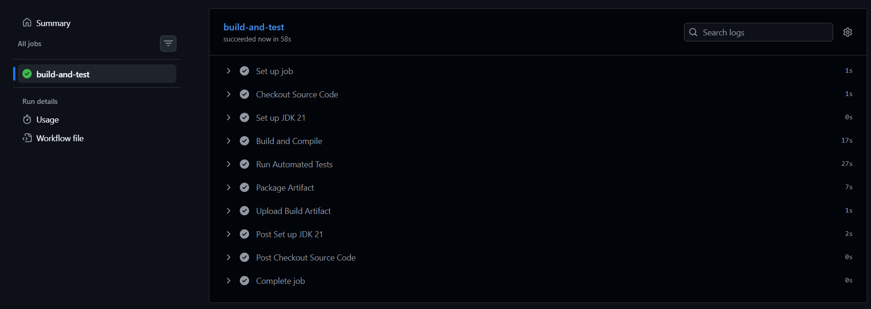
Figure 1: GitHub Actions automated testing suite
Conclusion
The combination of manual code reviews and an automated CI pipeline provides a defense against software defects. Identifying logical risks early in the review phase and catching regressions automatically in the CI phase allows the medical drone delivery system to be more robust and adhere to professional standards.

